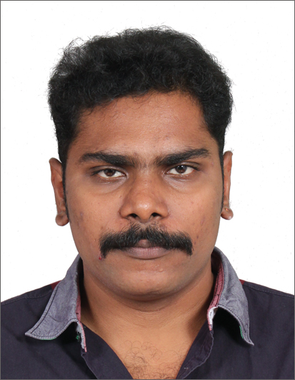

Ar. J. Naveen Balaji. M.Arch(Leibniz–Germany).,
No: 23, F-2, 1st Floor, Subramanya Nagar 2nd Street,
Kodambakkam, Chennai-600024.
Cell: 0091-9094249224; 0091-9176196063
E-Mail: nawin.asia@gmail.com

Career Profile:
Experimenting With Contemporary Architecture & Natural Systems. Seeking for a respective career as an Architectural Designer where I can utilize my Four years of experience in various projects and constructions on luxury houses, home units, industrial and commercial buildings, urban design, heritage and conservation sites.
Core strengths:
- Possess Extensive Knowledge of Architectural Designs, Plans & Specifications
- Proficient in 3D Studio Max, CINEMA 4D, Rhinoceros, AutoCAD, Adobe and other graphics communication programs.
- Comprehensive Knowledge of the Fundamental Principles of Architecture
- Familiar with the Terminology, Practices, Methods & Techniques of Architectural Drafting
- Extensive Knowledge of Preparing Complex Schematic Drawings from Oral Instructions & Rough Sketches
- Knowledge of Designing, Preparing Accurate Drawings & Specifications for Buildings
- Possess Demonstrated Leadership & Supervisory Skills
- Ability to Access Materials, Products & Make sound Selection Decisions
- Ability to Build & Maintain Good Working Relationships with Different Personnel
Other Skills:
- Ability to Multi-Task
- A Client-Centered Focus
- An Outgoing Personality
- A Team Player Mentality
- Comfortable with Freehand Drafting & Communication
- A Strong Commitment to Delivering World Class Service
- Resourceful
- Imaginative
- Discerning & Sophisticated Eye
- Strong Conceptual as well as Technical Abilities
Educational Summary:
Anna University* [School Of Architecture & Planning] – India. B.Arch.: (2002 – 2007)
Anna University* [School Of Architecture & Planning] – India. M.Arch.: (2011 – 2013)
1st Semester – 3rd Semester
Leibniz Universität Hannover* [Faculty of Architecture and Landscape Sciences] – Germany. M.Arch.: (2013)
4th Semester – (Urban Design Project @ Hamburg)

Professional Experience:
Lemorf Architects, Chennai
2008 - 2011
Senior Architect*
- Assigned & Handled the Tasks of Designing a Range of Projects like Universities, Resorts, Apartments, Offices & Residences
- Responsible for Preparing 3D Orientations for Initial Project Proposals
- Handled the Tasks of Managing a Team of Architects
- Conceptualized Special Projects like Booths, Landscapes & Signage
- Assigned the Tasks of Preparing Budget for Every Project
- Responsible for Reviewing & Assessing Proposals for Final Presentation
- Worked with City Engineers for Budget Preparation & Procurement of Materials
- Worked with City Consultants for Structural Design & Procurement of Services
Mathew & Ghosh Architects, Bangalore
2007 to 2008
Junior Architect*
- Responsible for Preparing Preliminary Design Sketches for Small and Large Complex Projects
- Handled the Tasks of Drawing & Drafting Work by Using 3D Studio Max, AutoCAD & Photoshop for each Assigned Project
- Handled the Responsibilities of Preparing Final Designs like Drafting and Specifications as per Project Approval
- Responsible for Conducting Surveys to Collect Data Required in Design Preparation
- Discussed the Requirements of Alterations & Repairs to be made with Concerned Officials
- Performed Other Essential Tasks as Delegated
Awards and Honors:
• Design Showcase 2010 Finalists Contested by:
[] http://www.glazette.com/design-showcase-finalists-127.html
• STAR ACHIEVER 2010* - Awarded by: NATIONAL INTEGRITY CULTURAL ACADEMY
• ARCHITECTURE EXCELLENCE AWARD 2011* - Awarded by: ALL INDIA ACHIEVERS FOUNDATION
• INDIRAGANDHI SADBHAVNA GOLD MEDAL AWARD 2012* - Awarded by: GLOBAL ECONOMIC PROGRESS & RESEARCH ASSOCIATION

Areas of Interest:
- Preparing 3D Orientations for Initial Project Proposals
- To make Effective Contribution in the Field by using 3D Studio Maximizing & Auto Cad Applications
- Preparing Preliminary Design Sketches for Small & Large Complex Projects
- Handling the Responsibilities of Preparing Final Designs & specifications as per Project Approval
- Conceptualizing Special Projects

Yours sincerely


Ar. J. Naveen Balaji. M.Arch(Leibniz–Germany).,
No: 23, F-2, 1st Floor, Subramanya Nagar 2nd Street,
Kodambakkam, Chennai-600024.
Date of Birth: 30/07/1984
Relationship status: Married

Cell: 0091-9094249224; 0091-9176196063
E-Mail: nawin.asia@gmail.com
Employment Status: Full Time

